**Chapter 1**

**Introduction**

* 1. **Introduction**

The term "Arrhythmia" refers to any change from the normal sequence of electrical impulses. The electrical impulses may happen too fast, too slowly, or erratically – causing the heart to beat too fast, too slowly, or erratically. When the heart doesn't beat properly, it can't pump blood effectively. When the heart doesn't pump blood effectively, the lungs, brain and all other organs can't work properly and may shut down or be damaged.The normal heart is a strong, muscular pump a little larger than a fist. It pumps blood continuously through the circulatory system.A heart rate that is too fast – above 100 beats per minute in adults – is called Tachycardia and a heart rate that is too slow – below 60 beats per minute – is called Bradycardia. Any interruption to the electrical impulses that cause the heart to contract can result in arrhythmia.

* 1. **Motivation**

Some of the main points that motivated us in pursuing this project are:

* The state of cardiac heart is generally reflected in the shape of electrocardiogram (ECG) waveform and heart rate. ECG, if properly analysed, can provide information regarding various arrhythmia diseases related to heart.
* Clinical observation of ECG can take long hours and can be very tedious. Moreover, visual analysis cannot be relied upon and the possibility of the analyst missing the vital information is high. Hence, computer-based analysis and classification of Arrhythmia diseases can be very helpful in diagnosis.
* Various contributions have been made in literature regarding detection and classification of ECG Arrhythmias. Most of them use either time or frequency domain representation of the ECG waveforms, based on which many specific features are defined, allowing the recognition between the beats belonging to different classes.
* The most difficult problem faced by today’s automatic ECG arrhythmia analysis is the large variation in the morphologies of ECG waveforms. Thus, our basic objective is to come up with a simple method having less computational time without compromising with the accuracy [5].
  1. **Methodology**

A fully automatic system for arrhythmia classification from signals acquired by an ECG device can be divided in four steps as follows:

1. ECG signal pre-processing: ECG signal pre-processing is carried out for reducing noise in ECG signals with the implementation of recursive digital filters [1] of the infinite impulse response (IIR).
2. Heartbeat segmentation: Heartbeat segmentation methods are used for detection of the R peak or the QRS complex. Two measures are usually considered for evaluating the accuracy of heartbeat segmentation: sensitivity and positive predictivity. In the following implementation this is achieved through Pan Tompkins algorithm [2].
3. Feature extraction: The features can be extracted in various forms directly from the ECG signal’s morphology in the time domain and/or in the frequency domain or from the cardiac rhythm. In the following implementation feature extraction is done using Discrete Wavelet Transform (DWT).
4. Learning/classification: Once the set of features has been defined from the heartbeats, models can be built from these data using Machine Learning algorithms for the Arrhythmia heartbeat classification. In the following implementation we make use of Decision Tree and Random Forest Algorithm to detect arrhythmia in patients.
   1. **Dataset**

The MIT-BIH Arrhythmia Database [3] was developed by Massachusetts Institute of Technology (MIT)in collaboration with Boston’s Beth Israel Hospital (BIH) in 1980 for Arrhythmia detection.The database contains 48 records, each containing two-channel ECG signals for 30 min duration selected from 24-hr recordings of 47 individuals (record 200 and 201 are from same patient). The subjects were 25 men aged 32 to 89 years, and 22 women aged 23 to 89 years.Each ECG record consists of two channel recordings. The first channel recording uses modified lead limb II (MLII) while the second channel recording commonly uses lead V1. Other types of electrodes like V2, V5 and V4 are also used for the second channel recording. The first 23 (100-124) recordings correspond to the routine clinical recordings while the remaining recordings (200-234) contain the complex Arrhythmias.In most records, the upper signal is a modified limb lead II (MLII), obtained by placing the electrodes on the chest. The lower signal is usually a modified lead V1 (occasionally V2 or V5, and in one instance V4); as for the upper signal, the electrodes are also placed on the chest. This configuration is routinely used by the BIH Arrhythmia Laboratory. Normal QRS complexes are usually prominent in the upper signal. The lead axis for the lower signal may be nearly orthogonal to the mean cardiac electrical axis, however (i.e., normal beats are usually biphasic and may be nearly isoelectric). Thus, normal beats are frequently difficult to discern in the lower signal, although ectopic beats will often be more prominent. MLII and V5 are the orthogonal signals which means that QRS peaks are detected in MLII electrode, and remaining part of the signal is detected perfectly in the other orthogonal signal used.

* 1. **Workflow**

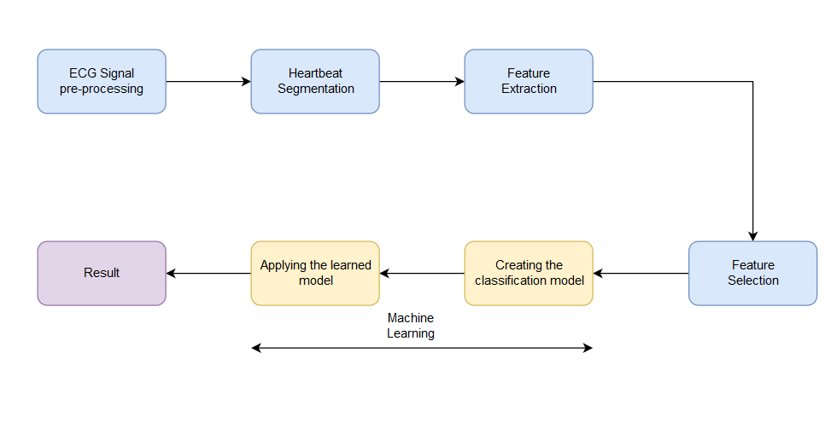

**Fig 1.1:** Workflow of the arrhythmia identification system

* 1. **Arrhythmia**

Arrhythmia is a group of conditions where the heartbeat is irregular, too slow, or too fast. It occurs when the electrical signals to the heart that coordinate heartbeats are not working properly [8]. For instance, some people experience irregular heartbeats, which may feel like a racing heart or fluttering. A heart rate that is too fast – above 100 beats per minute in adults – is called Tachycardia and a heart rate that is too slow – below 60 beats per minute – is called Bradycardia. Any interruption to the electrical impulses that cause the heart to contract can result in arrhythmia.Each day the average heart beats (expands and contracts) 100,000 times and pumps about 2,000 gallons of blood through the body. In a 70-year lifetime, an average human heart beats more than 2.5 billion times.

* + 1. **Causes of Arrhythmia**

Arrhythmia can be caused by several reasons. Some of the main causes are:

* Blocked arteries in your heart (coronary artery disease)
* Electrolyte imbalances in your blood (such as sodium or potassium).
* Irregular heart rhythms
* High blood pressure
* Overactive thyroid gland (hyperthyroidism) or Underactive thyroid gland (hypothyroidism).
* Smoking, drinking too much alcohol or caffeine, drug abuse.
* Stress
* Certain medications and supplements, including over-the-counter cold and allergy drugs and nutritional supplements
* Diabetes
  + 1. **Types of Arrhythmia**

The types of Arrhythmia include:

1. Premature atrial contractions: These are early extra beats that originate in the atria (upper chambers of the heart). They are harmless and do not require treatment.
2. Premature ventricular contractions (PVCs): These are among the most common arrhythmias and occur in people with and without heart disease. This is the skipped heartbeat we all occasionally experience. In some people, it can be related to stress, too much caffeine or nicotine, or too much exercise. But sometimes, PVCs can be caused by heart disease or electrolyte imbalance. People who have a lot of PVCs, and/or symptoms associated with them, should be evaluated by a heart doctor. However, in most people, PVCs are usually harmless and rarely need treatment.
3. Atrial fibrillation: Atrial fibrillation is a very common irregular heart rhythm that causes the atria, the upper chambers of the heart, to contract abnormally.
4. Atrial flutter: This is an arrhythmia caused by one or more rapid circuits in the atrium. Atrial flutter is usually more organized and regular than atrial fibrillation. This arrhythmia occurs most often in people with heart disease and in the first week after heart surgery. It often converts to atrial fibrillation.
5. AV nodal re-entrant tachycardia: A rapid heart rate due to more than one pathway through the AV node. It can cause heart palpitations, fainting, or heart failure. In many cases, it can be terminated using a simple manoeuvres, such as breathing in and bearing down, and others performed by a trained medical professional. Some drugs can also stop this heart rhythm.
6. Sinus node dysfunction: A slow heart rhythm due to an abnormal SA (sinus) node. Significant sinus node dysfunction that causes symptoms is treated with a pacemaker.
7. Heart block: A delay or complete block of the electrical impulse as it travels from the sinus node to the ventricles. The level of the block or delay may occur in the AV node or HIS-Purkinje system. The heart may beat irregularly and, often, more slowly. If serious, heart block is treated with a pacemaker.
   * 1. **Symptoms of Arrhythmia**

An arrhythmia can be silent and not cause any symptoms. A doctor can detect an irregular heartbeat during a physical exam by taking your pulse or through an ECG.

When symptoms of an arrhythmia occur, they may include:

* Palpitations, a feeling of skipped heart beats, fluttering or feeling that your heart is "running away".
* Pounding in your chest.
* Dizziness or feeling light-headed.
* Fainting.
* Shortness of breath.
* Chest discomfort.
* Weakness or fatigue (feeling very tired)

**Chapter 2**

**Electrocardiogram**

* 1. **Introduction**

Electrocardiogram (ECG) is a diagnosis tool that reported the electrical activity of heart recorded by skin electrode. The morphology and heart rate reflect the cardiac health of human heart beat. It is a non-invasive technique that means this signal is measured on the surface of human body, which is used in identification of the heart diseases. In the following chapter various concepts related to ECG and the human heart are discussed.

* 1. **The Human Heart**

The heart is composed of four chambers which make up two pumps. There are two upper chambers, called the right and left atria, and two lower chambers, called the right and left ventricles. The purpose of the Atria is receiving blood from the body, the right atrium receives oxygen-devoid blood from the body and the left atrium receives oxygen-rich blood from the lungs.

The heart is controlled by a very precise electrical system. The right pump receives the blood returning from the body and pumps it to the lungs. The left pump gets blood from the lungs and pumps it out to the rest of the body. Each Pump is made up of two chambers, an atrium and a ventricle. The atrium collects the Incoming blood, and when it contracts, transfers the blood to the ventricle. When the ventricle contracts the blood is pumped away from the heart. The pumping action of the heart is regulated by the pacemaker region, or sinoatrial node, located in the right atrium. An electrical impulse is created in this region by the diffusion of calcium ions, sodium ions, and potassium ions across the membranes of cells. The impulse created by the motion of these ions is first transferred to the atria, causing them to contract and push blood into the ventricles. After about 150 milliseconds, the impulse moves to the ventricles, causing them to contract and pump blood away from the heart. This system regulates the mechanical pumping action of the heart so that the entire cardiovascular system can function properly.

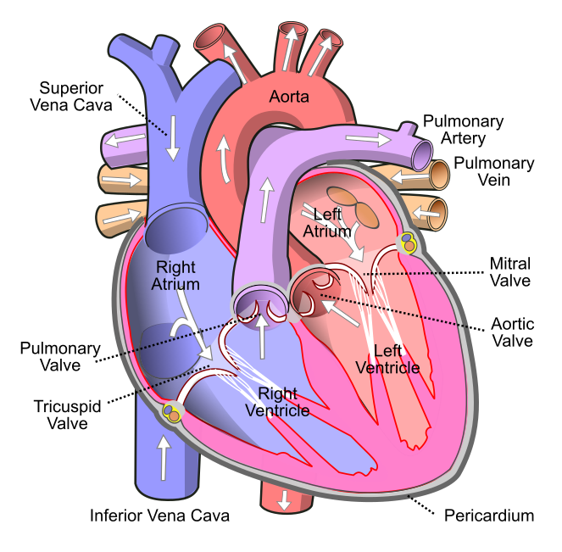

**Fig 2.1:** The Human Heart

* + 1. **Cardiac Cycle**

The cardiac cycle refers to the sequence of events in which the heart contracts and relaxes with every heartbeat. The period during which the ventricles contract, forcing blood out into the aorta and main pulmonary artery, is known as systole, while the period during which the ventricles relax and refill with blood is known as diastole. The atria and ventricles work in concert, so in systole when the ventricles are contracting, the atria are relaxed and collecting blood. When the ventricles are relaxed in diastole, the atria contract to pump blood to the ventricles. This coordination ensures blood is pumped efficiently to the body.

At the beginning of the cardiac cycle, the ventricles are relaxing. As they do so, they are filled by blood passing through the open mitral and tricuspid valves. After the ventricles have completed most of their filling, the atria contract, forcing further blood into the ventricles and priming the pump. Next, the ventricles start to contract. As the pressure rises within the cavities of the ventricles, the mitral and tricuspid valves are forced shut. As the pressure within the ventricles rises further, exceeding the pressure with the aorta and pulmonary arteries, the aortic and pulmonary valves open. Blood is ejected from the heart, causing the pressure within the ventricles to fall. Simultaneously, the atria refill as blood flows into the right atrium through the superior and inferior vena cavae, and into the left atrium through the pulmonary veins. Finally, when the pressure within the ventricles falls below the pressure within the aorta and pulmonary arteries, the aortic and pulmonary valves close. The ventricles start to relax, the mitral and tricuspid valves open, and the cycle begins again.

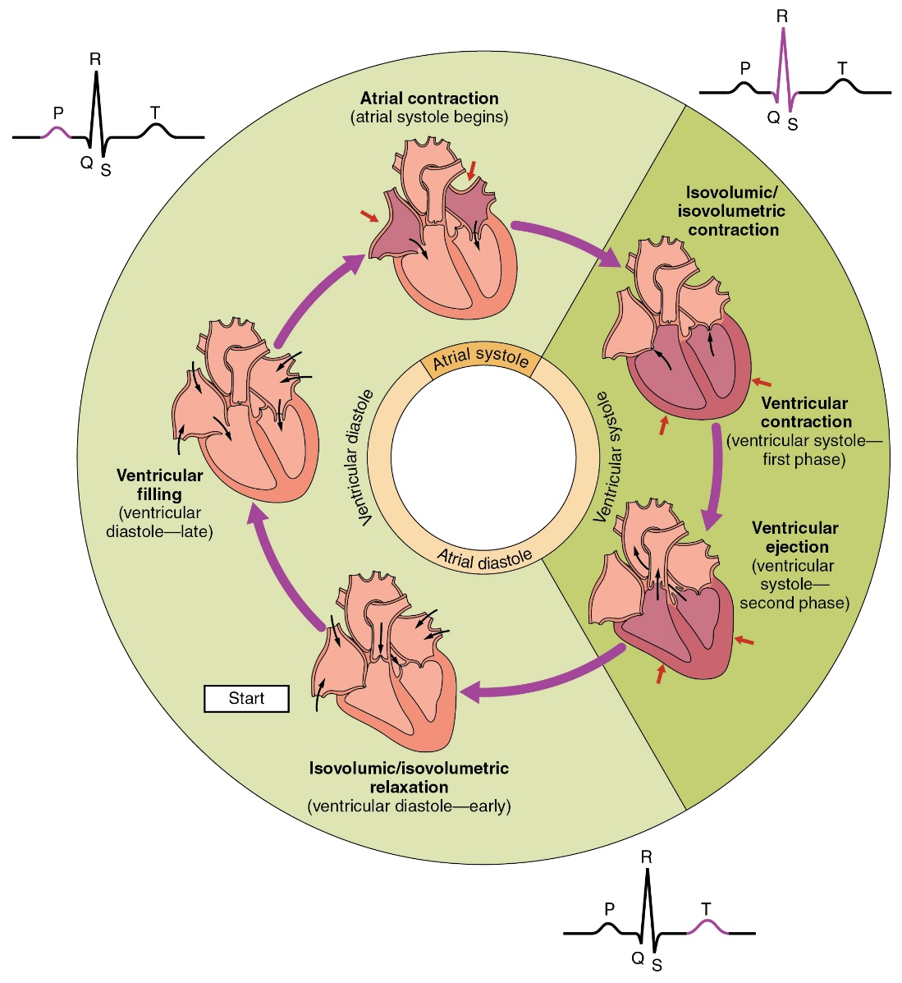

**Fig 2.2:** The cardiac cycle as correlated to the ECG

* + 1. **Electrical Conduction**

The normal rhythmical heartbeat, called sinus rhythm, is established by the sinoatrial node, the heart's pacemaker. Here an electrical signal is created that travels through the heart, causing the heart muscle to contract.

The Sino-atrial node (also known as SA Node) is found in the upper part of the right atrium. The electrical signal generated by the sinoatrial node travels through the right atrium in a radial way that is not completely understood. It travels to the left atrium via Bachmann's bundle, such that the muscles of the left and right atria contract together. The signal then travels to the atrio-ventricular node also known as AV node. This is found at the bottom of the right atrium in the atrioventricular septum—the boundary between the right atrium and the left ventricle. The septum is part of the cardiac skeleton, tissue within the heart that the electrical signal cannot pass through, which forces the signal to pass through the atrioventricular node only.The signal then travels along the bundle of His to left and right bundle branches through to the ventricles of the heart. In the ventricles the signal is carried by specialized tissue called the Purkinje fibers which then transmit the electric charge to the heart muscle.

* + 1. **Heart Rate**

The normal resting heart rate is called the sinus rhythm, created and sustained by the sinoatrial node, a group of pace making cells found in the wall of the right atrium. Cells in the sinoatrial node do this by creating an action potential. The cardiac action potential is created by the movement of specific electrolytes into and out of the pacemaker cells. The action potential then spreads to nearby cells.

The adult resting heart rate ranges from 60 to 100 bpm. The resting heart rate of a new-born can be 129 beats per minute (bpm) and this gradually decreases until maturity.An athlete's heart rate can be lower than 60 bpm. During exercise the rate can be 150 bpm with maximum rates reaching from 200 to 220 bpm.

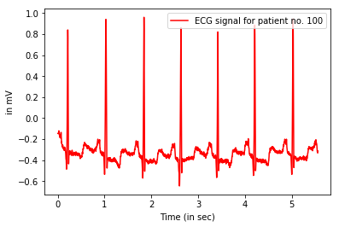

**Fig 2.3:** ECG signal for one of the patients in MIT-BIH Database

* 1. **ECG Signal**

Electrocardiography (ECG) is the process of recording the electrical activity of the heart over a period of time using electrodes placed over the skin. These electrodes detect the tiny electrical changes on the skin that arise from the heart muscle's electrophysiologic pattern of depolarizing and repolarizing during each heartbeat. It is very commonly performed to detect any cardiac problems [3].

In a conventional 12-lead ECG, ten electrodes are placed on the patient's limbs and on the surface of the chest. The overall magnitude of the heart's electrical potential is then measured from twelve different angles ("leads") and is recorded over a period of time (usually ten seconds) [6]. In this way, the overall magnitude and direction of the heart's electrical depolarization is captured at each moment throughout the cardiac cycle. The graph of voltage versus time produced by this non-invasive medical procedure is an electrocardiogram.

The difference of electrical potential between the pointsmarked by the electrodes on the skin, usually is enhancedwith the aid of an instrumentation (operational) amplifier withoptic isolation. Then, the signal is submitted to a high-passfilter; and as a second stage, submitted to an antialiasinglow-pass filter. Finally, it appears in an analogical to digital converter.

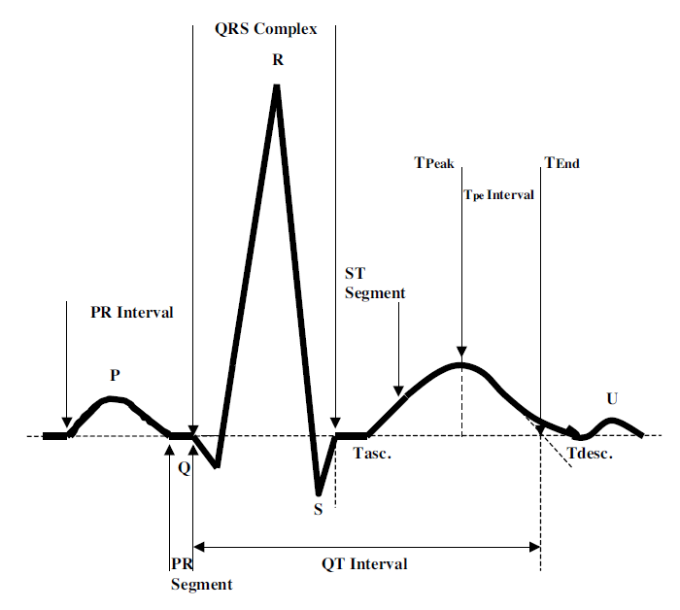

**Fig 2.4:** ECG of a heart in normal sinus rhythm

There are three main components to an ECG: The P wave, which represents the depolarization of the atria; the QRS complex, which represents the depolarization of the ventricles; and the T wave, which represents the repolarization of the ventricles. It can also be further broken down into the following:

* P is the atrial systole contraction pulse
* Q is a downward deflection immediately preceding the ventricular contraction
* R is the peak of the ventricular contraction
* S is the downward deflection immediately after the ventricular contraction
* T is the recovery of the ventricles
* U is the successor of the T-wave but it is small and not always observed

The orderly pattern of depolarization gives rise to the characteristic ECG tracing. To the trained clinician, an ECG conveys a large amount of information about the structure of the heart and the function of its electrical conduction system [6]. Among other things, an ECG can be used to measure the rate and rhythm of heartbeats, the size and position of the heart chambers, the presence of any damage to the heart's muscle cells or conduction system, the effects of heart drugs, and the function of implanted pacemakers.

* + 1. **Electrodes and Leads**

Electrodes are the actual conductive pads attached to the body surface. Any pair of electrodes can measure the electrical potential difference between the two corresponding locations of attachment. Such a pair forms a lead. However, "leads" can also be formed between a physical electrode and a virtual electrode, known as the Wilson's central terminal, whose potential is defined as the average potential measured by three limb electrodes that are attached to the right arm, the left arm, and the left foot, respectively.

Commonly, 10 electrodes attached to the body are used to form 12 ECG leads, with each lead measuring a specific electrical potential difference.

Leads are broken down into three types: limb; augmented limb; and precordial or chest. The 12-lead ECG has a total of three limb leads and three augmented limb leads arranged like spokes of a wheel in the coronal plane (vertical), and six precordial leads or chest leads that lie on the perpendicular transverse plane (horizontal).

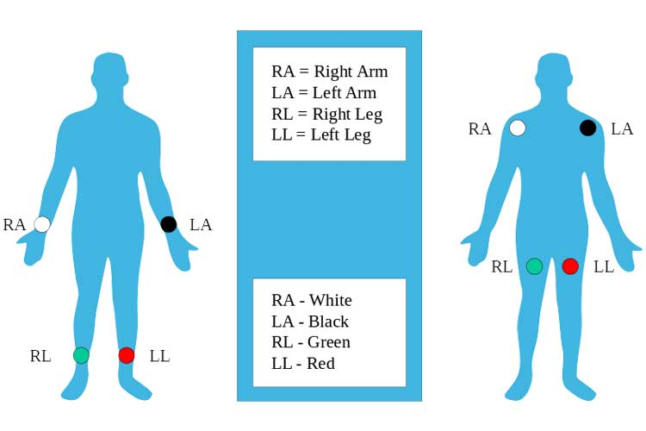

**Fig 2.5:**Proper placement of the limb electrodes

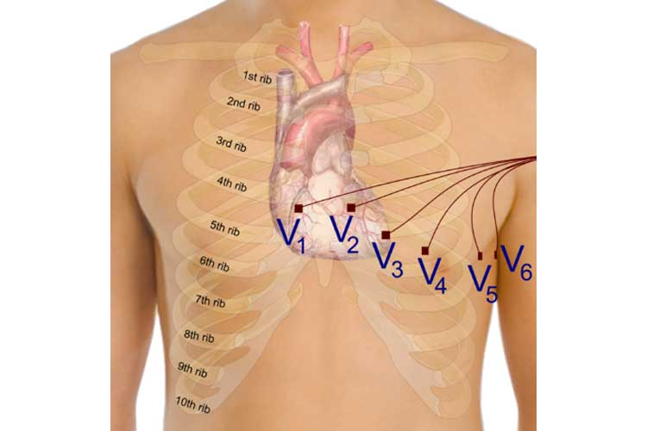

**Fig 2.6:**Placement of the precordial electrodes

In medical settings, the term leads are also sometimes used to refer to the electrodes themselves, although this is technically incorrect. This misuse of terminology can be the source of confusion.

The 10 electrodes in a 12-lead ECG are listedin Table 2.1

**Table 2.1:**Electrodes name and placement

|  |  |
| --- | --- |
| Electrode name | Electrode placement |
| RA | On the right arm, avoiding thick muscle. |
| LA | In the same location where RA was placed, but on the left arm. |
| RL | On the right leg, lower end of inner aspect of calf muscle. (Avoid bony prominences) |
| LL | In the same location where RL was placed, but on the left leg. |
| V1 | In the fourth intercostal space (between ribs 4 and 5) just to the right of the sternum (breastbone). |
| V2 | In the fourth intercostal space (between ribs 4 and 5) just to the left of the sternum. |
| V3 | Between leads V2 and V4. |
| V4 | In the fifth intercostal space (between ribs 5 and 6) in the mid-clavicular line. |
| V5 | Horizontally even with V4, in the left anterior axillary line. |
| V6 | Horizontally even with V4 and V5 in the mid-axillary line. |

* + 1. **Amplitudes and Intervals**

All the waves on an ECG tracing and the intervals between them have a predictable time duration, a range of acceptable amplitudes (voltages), and a typical morphology. Any deviation from the normal tracing is potentially pathological and therefore of clinical significance [6].For ease of measuring the amplitudes and intervals, an ECG is printed on graph paper at a standard scale: each 1 mm (one small box on the standard ECG paper) represents 40 milliseconds of time on the x-axis, and 0.1 millivolts on the y-axis.

There are many features present in an ECG wave. The features are:

1. P wave: The P wave represents depolarization of the atria. Atrial depolarization spreads from the SA node towards the AV node, and from the right atrium to the left atrium.The P wave is typically upright in most leads except for aVR; an unusual P wave axis (inverted in other leads) can indicate an ectopic atrial pacemaker. If the P wave is of unusually long duration, it may represent atrial enlargement. Typically, a large right atrium gives a tall, peaked P wave while a large left atrium gives a two-humped bifid P wave. The duration of a P wave is generally less than 80 ms.
2. PR Interval: The PR interval is measured from the beginning of the P wave to the beginning of the QRS complex. This interval reflects the time the electrical impulse takes to travel from the sinus node through the AV node.A PR interval shorter than 120 ms suggests that the electrical impulse is bypassing the AV node, as in Wolf-Parkinson-White syndrome. A PR interval consistently longer than 200 ms diagnoses first degreeatrioventricular block. The PR segment (the portion of the tracing after the P wave and before the QRS complex) is typically completely flat but may be depressed in pericarditis. The duration of a PR interval is between 120-200 ms.
3. QRS complex: The QRS complex represents the rapid depolarization of the right and left ventricles. The ventricles have a large muscle mass compared to the atria, so the QRS complex usually has a much larger amplitude than the P wave.If the QRS complex is wide (longer than 120 ms) it suggests disruption of the heart's conduction system, such as in LBBB, RBBB, or ventricular rhythms such as ventricular tachycardia. Metabolic issues such as severe hyperkalemia, or tricyclic antidepressant overdose can also widen the QRS complex. An unusually tall QRS complex may represent left ventricular hypertrophy while a very low-amplitude QRS complex may represent a pericardial effusion or infiltrative myocardial disease.
4. ST segment: The ST segment connects the QRS complex and the T wave; it represents the period when the ventricles are depolarized.It is usually isoelectricbut may be depressed or elevated with myocardial infarction or ischemia. ST depression can also be caused by LVH or digoxin. ST elevation can also be caused by pericarditis, Brugada syndrome, or can be a normal variant (J-point elevation).
5. T wave: The T wave represents the repolarization of the ventricles. It is generally upright in all leads except aVR and lead V1.Inverted T waves can be a sign of myocardial ischemia, left ventricular hypertrophy, high intracranial pressure, or metabolic abnormalities. Peaked T waves can be a sign of hyperkalemia or very early myocardial infarction. The duration of a T wave is about 160 ms.
6. U wave: The U wave is hypothesized to be caused by the repolarization of the interventricular septum. It normally has a low amplitude, and even more often is completely absent.If the U wave is very prominent, suspect hypokalemia, hypercalcemia or hyperthyroidism
   1. **Arrhythmias in ECG signal**

The normal rhythm of the heart where there is no disease or disorder in the morphology of ECG signal is called Normal sinus rhythm (NSR) [5]. The heart rate of NSR is generally characterized by 60 to 100 beats per minute. The regularity of the R-R interval varies slightly with the breathing cycle. When the heart rate increases above 100 beats per minute, the rhythm is known as sinus tachycardia. This is not an arrhythmia but a normal response of the heart which demand for higher blood circulation. If the heart rate is too slow then this is known as bradycardia and this can adversely affect vital organs. When the heart rate is too fast, the ventricles are not filled before contraction for which pumping efficiency drops, adversely affecting perfusion.

* + 1. **Sinus Node Arrhythmias**

This type of arrhythmia arises from the S-A node of heart. As the electrical impulse is generated from the normal pacemaker, the characteristic feature of these arrhythmias is that P wave morphology of the ECG is normal. These arrhythmias are the following types: Sinus arrhythmia, Sinus bradycardia, and Sinus arrest etc.

* + 1. **Atrial Arrhythmias**

Atrial arrhythmias originate outside the S-A node but within the atria in the form of electrical impulses. These arrhythmias types are given bellow, Premature Atrial Contractions (PAC) thisarrhythmia results an abnormal P-wave morphology followed by a normal QRS complex and a T-wave. This happens because of an ectopic pacemaker firing before the S-Anode. PACs may occur as a couplet where two PACs are generated consecutively. When three or more consecutive PACs occur, the rhythm is Atrial Tachycardia. The heart rate atrial tachycardia is fast and ranges from 160 to 240 beats per minute in atrial tachycardia. Frequently atrial tachycardia is accompanied by feelings of palpitations, nervousness, or anxiety.

In atrial flutter, the atrial rate is very fast, ranging from 240 to 360 per minute. The abnormal P-waves occur regularly and so quickly that they take morphology of sawtoothwaveform which is called flutter (F) waves.

The atrial rate exceeds 350 beats per minute in this type of arrhythmias. This arrhythmia occurs because of uncoordinated activation and contraction of different parts of the atria. The higher atria rate and uncoordinated contraction leads to ineffective pumping of blood into the ventricles. Atrial fibrillation may be intermittent, occurring in paroxysms (short bursts) or chronic.

* + 1. **Junctional Arrhythmias**

Junctional arrhythmias are originated within the A-V junction in the form of the impulse comprising the A-V node and its bundle. The abnormal in P wave morphology occurs because of these arrhythmias. The polarity of the abnormal P-wave would be opposite to that of the normal sinus P-wave since depolarization is propagated in the opposite direction – from the A-V node towards the atria. Premature Junctional Contractions (PJC) It is a ventricular contraction initiated by an ectopic pacemaker in the atrio-ventricular (AV)node.

In premature junctional escape contraction, a normal-looking QRS complex prematurely appears, but without a preceding P-wave, but the morphology of T-wave is normal.

* + 1. **Ventricular arrhythmias**

In this type of arrhythmias, the impulses originate from the ventricles and move outwards to the rest of the heart. In Ventricular arrhythmias, the QRS-complex is wide and bizarre in shape. Premature Ventricular Contractions (PVC) In PVC the abnormality is originated from ventricles. PVCs usually do not depolarize the atria or the S-A node and hence the morphology of P-waves maintain their underlying rhythm and occur at the expected time. PVCs may occur anywhere in the heart beat cycle. PVCs are described as isolated if they occur singly, and as couplets if two consecutive PVCs occur.

In Ventricular Tachycardia (VT)heart rate of ventricular tachycardia is 110 to 250 beats per minute. In VT the QRS complex is abnormally wide, out of the ordinary in shape, and of a different direction from the normal QRS complex. VT is considered life-threatening as the rapid rate may prevent effective ventricular filling and result in a drop in cardiac output.

Ventricular fibrillation occurs when numerous ectopic pacemakers in the ventricles cause different parts of the myocardium to contract at different times in a non-synchronized fashion. Ventricular flutter exhibits a very rapid ventricular rate with a saw-tooth like ECG waveform.

* + 1. **Atrioventricular Blocks**

It is the normal propagation of the electrical impulse along the conduction pathways to the ventricles, but the block may delay or completely prevent propagation of the impulse to the rest of the conduction system. A first-degree AV block is occurred when all the P-waves are conducted to the ventricles, but the PR-interval is prolonged. Second-degree AV blocks are occurred when some of the P waves fail to conduct to the ventricles. In third-degree AV block, the rhythm of the P-waves is completely dissociated from the rhythm of the QRS complexes.

* + 1. **Bundle Branch Blocks**

Bundle branch block cease in the conduction of the impulse from the AV-node to the whole conduction system. Due to this block there may occur myocardial infarction or cardiac surgery. The bundle branch block beat is categories into two types. These are Left bundle branch block beat (LBBB) and Right bundle branch block beat (RBBB). In LBBB the left bundle branch will prevent the electrical impulses from the A-V node from depolarizing the left ventricular myocardium in the normal way. When the right bundle branch is blocked, the electrical impulse from the AV node is not able propagate to the conduction network to depolarize the right ventricular myocardium.

**Chapter 3**

**Preprocessing and Segmentation**

* 1. **Introduction**

The first two steps of the Arrhythmia identification system are ECG signal pre-processing and heartbeat segmentation. The techniques employed during the pre-processing stage directly influences the final accuracy. The pre-processing stage is important for noise removal from the ECG signal. The heartbeat segmentation is performed using Pan Tompkins algorithm. The heartbeat segmentation is employed so that analysis of each heartbeat can be done.

* 1. **Preprocessing of ECG signal**

The preprocessing of ECG signal is performed to remove the base line wander, motion artifacts and other interruptions of original recorded signal. In telemedicine applications, transmission of ECG signals over a wireless channel is often affected by noises due to improper channel. The noises are normally modelled as white Gaussian noise. In some applications, white Gaussian noise is considered as a general frequency noise source and is added to the uncontaminated ECG signals. Many filtering and noise removal techniques have been adopted for the white noise removal.

Among all proposals for reducing noise in ECG signals, the simplest and most widely used is the implementation of recursive digital filters of the infinite impulse response (IIR), which was made computationally possible with the advance in microcontrollers and microprocessors. These methods work well for the attenuation of the known frequency bands, such as the noise coming from the electrical network (50 Hz or 60 Hz), since they allow quick and easy application of the reject-band-filter [1]. The problem with this approach is that the frequency of the noise is not always known, which can be solved by applying filters for various frequency bands to the signal. However, the indiscriminate use of filters, i.e., high-pass and low-pass ones, distorts the morphology of the signal, and many times, makes it unusable for diagnosing cardiac diseases.

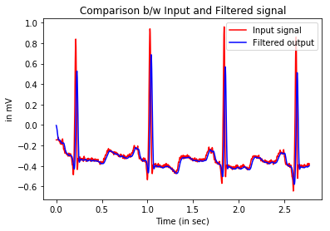

**Fig 3.1:** Comparison between Input and filtered signal

* 1. **Heartbeat Segmentation**

Heartbeat segmentation methods (i.e., detection of the R peakor the QRS complex) have been studied for more than threedecades and the generations of these algorithms and newly developing methods reflect the evolutionof the processing power of computers. With the facility ofusing faster processing computers, authors stopped worryingabout computational cost and started concentrating on theheartbeat segmentation accuracy. Two measures are usuallyconsidered for evaluating the accuracy of heartbeat segmentation: sensitivity and positive predictivity [1].

* Sensitivity refers to the test's ability to correctly detect ill patients who do have the condition.In the example of a medical test used to identify a disease, the sensitivity of the test is the proportion of people who test positive for the disease among those who have the disease. Mathematically, this can be expressed as:

SensitivitySEG=TP/(TP+FN)

* The positive predictivity is defined as

Positive predictivity = TP/(TP + FP),

where TP (True Positive) means heartbeat is detected by the algorithm and was also present in the patients data, FP (False Positive) means that heartbeat was not present in the patients data but was detected by the algorithm, and FN (False Negative) means heartbeat was not detected by the algorithm but was present in the patients data.

* + 1. **Pan Tompkins Algorithm**

Pan and Tompkins (PT), also known as the low-pass differentiation algorithm (LPD), introduced a major evolution in ECG signal processing in 1985. Slope, amplitude and width information were used to detect QRS complexes in PT algorithm. The QRS detection was implemented through three detection steps: linear digital filtering, non-linear transformations, and decision rule algorithms [1]. The PT method does not consume significant power rates. In the process, a raw ECG signal is passed into an A/D converter at a sampling frequency of about 200 Hz after filtration by an analog band-pass filter to limit the band of the ECG signal at about 50 Hz before digitization. Pattern recognition tasks involve a preprocessing step, which consists of a band-pass filter cascaded into a low-pass and a high-pass filter configuration. The low-pass filter is used to limit the operating range of an ECG signal and to reduce higher frequency noise effects while the high-pass filter is used to highlight the onset of each QRS complex.

The Pan Tompkins algorithm consists of the following steps:

* Band-pass filtering
* Differentiation
* Squaring
* Moving window integration
* Adaptive Thresholding

The processing steps of QRS complex detection. The P wave is a rounded peak occurred before the QRS complex. Therefore, the P wave can be found based on the location of the QRS complex. One of the most popular QRS detection algorithms, included in virtually all biomedical signal processing textbooks, is that introduced by Pan and Tompkins. An overview of the algorithm follows. The signal passes through filtering, derivation, squaring, and integration phases before thresholds are set and QRS complexes are detected In the first step the algorithm passes the signal through a low pass and a high pass filter in order to reduce the influence of the muscle noise, the power line interference, the baseline wander and the T-wave interference.

**Band-pass filtering:**The band pass filter for the QRS detection algorithm reduces noise in the ECG signal by matching the spectrum of the average QRS complex. This attenuates noise due to muscle noise, power line interference, baseline wander, T wave interference. Filter implemented is a fast, real-time recursive filter in which poles are located to cancel zeros on the unit circle of the z plane . This approach results in a filter design with integer coefficients. The filter implemented in this algorithm is composed of cascaded high pass and low pass IIR filters [2].

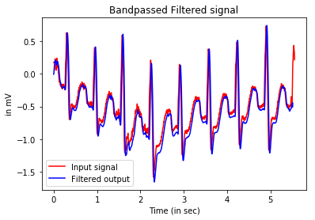

**Fig 3.2:** Bandpass filtering stage output

**Derivative Operator:**The next processing step is differentiation, standard technique for finding the high slopes that normally distinguish the QRS complexes from other ECG waves. The derivative procedure suppresses the low frequency components of P and T waves and provides a large gain to the high-frequency components arising from the high slopes of the QRS Complex [2].

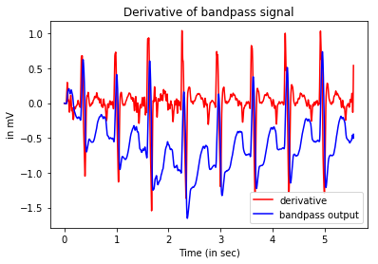

**Fig 3.3:** Derivative of Bandpass signal

**Squaring:**The squaring operation makes the result positive and emphasizes large differences resulting from QRS complexes; the small differences arising from P and T waves are suppressed. The high frequency components in the signal related to the QRS complex are further enhanced. This is a nonlinear transformation that consists of point by point squaring of the signal samples [2].

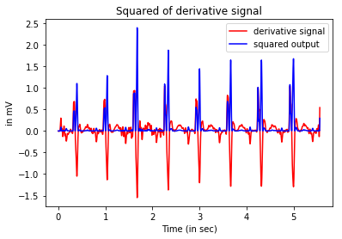

**Fig 3.4:** Squared of derivative signal

**Moving Window Integration:** The squared waveform passes through a moving window integrator. This integrator sums the area under the squared waveform over a suitable interval, advances one sample interval, and integrates the new predefined interval window. The half-width of window has been chosen as 27 to include the time duration of extended abnormal QRS complexes, but short enough that it does not overlap both a QRS complex and a T-wave. MA (moving average) filter extracts features in addition to the slope of the R wave [2].

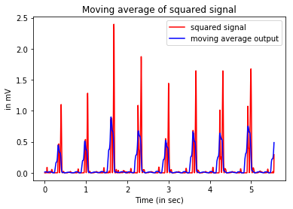

**Fig 3.5:** Moving average of squared signal

**Adaptive Threshold:** The result of the moving window is then passed through the adaptive threshold. Adaptive threshold helps in distinguishing the signal peak from noise peak by comparing the current signal value with the threshold value. If the signal value is more than threshold, then QRS complex is detected and all the other signal values below the threshold is noise value. The threshold value is adaptive which means it takes real time signal inputs to compute the threshold which would be used to classify next signal point. Below figure shows how threshold (shown in blue line) varies with the bandpass output of the raw signal (shown in red).

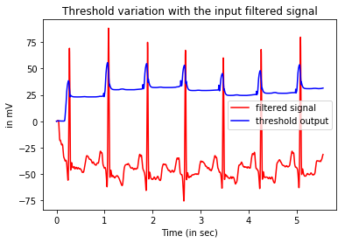

**Fig 3.6:** Threshold variation with the input filtered signal

We used the MIT/BIH arrhythmia database to evaluate the heartbeat segmentation algorithm. The database consists of 48 half-hour recordings for a total of 24 h of ECG data. The database is on four-channel FM magnetic tape. Channels I and 2are the two-channel ECG signals.

**Table 3.1:** Results of Pan-Tompkins using the MIT-BIH database

|  |  |  |  |  |  |
| --- | --- | --- | --- | --- | --- |
| Record no. | Present  Total Heartbeat | Predicted  Total Heartbeat | TP | FP | FN |
| 100 | 2274 | 2273 | 2273 | 0 | 1 |
| 101 | 1874 | 1867 | 1865 | 2 | 9 |
| 102 | 2192 | 2200 | 2173 | 27 | 19 |
| 103 | 2091 | 2080 | 2079 | 1 | 12 |
| 104 | 2311 | 2164 | 1935 | 229 | 376 |
| 105 | 2691 | 2619 | 2495 | 124 | 196 |
| 106 | 2098 | 2006 | 2000 | 6 | 98 |
| 107 | 2140 | 2583 | 1961 | 622 | 179 |
| 108 | 1824 | 2139 | 1728 | 411 | 96 |
| 109 | 2535 | 2529 | 2522 | 7 | 13 |
| 111 | 2133 | 2130 | 2124 | 6 | 9 |
| 112 | 2550 | 2541 | 2540 | 1 | 10 |
| 113 | 1796 | 1795 | 1795 | 0 | 1 |
| 114 | 1890 | 1878 | 1878 | 0 | 12 |
| 115 | 1962 | 1954 | 1953 | 1 | 9 |
| 116 | 2421 | 2392 | 2386 | 6 | 35 |
| 117 | 1539 | 1537 | 1535 | 2 | 4 |
| 118 | 2301 | 2280 | 2279 | 1 | 22 |
| 119 | 2094 | 1989 | 1988 | 1 | 106 |
| 121 | 1876 | 1865 | 1860 | 5 | 16 |
| 122 | 2479 | 2479 | 2478 | 1 | 1 |
| 123 | 1519 | 1517 | 1516 | 1 | 3 |
| 124 | 1634 | 1612 | 1610 | 2 | 24 |
| 200 | 2792 | 2661 | 2592 | 69 | 200 |
| 201 | 2039 | 1955 | 1895 | 60 | 144 |
| 202 | 2146 | 2130 | 2121 | 9 | 25 |
| 203 | 3108 | 2949 | 2855 | 94 | 253 |
| 205 | 2672 | 2656 | 2652 | 4 | 20 |
| 207 | 2385 | 2280 | 2143 | 137 | 242 |
| 208 | 3040 | 2717 | 2711 | 6 | 329 |
| 209 | 3052 | 3007 | 3006 | 1 | 46 |
| 210 | 2685 | 2611 | 2602 | 9 | 83 |
| 212 | 2763 | 2749 | 2748 | 1 | 15 |
| 213 | 3294 | 3243 | 3243 | 0 | 51 |
| 214 | 2297 | 2304 | 2259 | 45 | 38 |
| 215 | 3400 | 3352 | 3349 | 3 | 51 |
| 217 | 2280 | 3286 | 2198 | 1088 | 82 |
| 219 | 2312 | 2155 | 2153 | 2 | 159 |
| 220 | 2069 | 2048 | 2048 | 0 | 21 |
| 221 | 2462 | 2501 | 2351 | 150 | 111 |
| 222 | 2634 | 2486 | 2483 | 3 | 151 |
| 223 | 2643 | 2511 | 2510 | 1 | 133 |
| 228 | 2141 | 936 | 916 | 20 | 1225 |
| 230 | 2466 | 2257 | 2257 | 0 | 209 |
| 231 | 2011 | 1572 | 1570 | 2 | 441 |
| 232 | 1816 | 1787 | 1780 | 7 | 36 |
| 233 | 3152 | 3078 | 3078 | 0 | 74 |
| 234 | 2764 | 2750 | 2749 | 1 | 15 |

After evaluating these parameters for each of the 48 records available in the MIT-BIH database we found the following results related to sensitivity and positive predictivity.

Sensitivity is defined as ratio of total no of true positive heartbeat to sum of total true positive and false negative heartbeat. Positive predictivityis defined as ratio of total no of true positive heartbeat to sum of total true positive and false positive heartbeat.

So.from the table 3.1 we get,

Sensitivity: 95.2%

Positive predictivity: 97.1%

**Chapter 4**

**Feature Extraction**

**4.1 Introduction**

The feature extraction stage is the key to the success in theheartbeat classification of the arrhythmia using the ECG signal. Any information extracted from the heartbeat used todiscriminate its type maybe considered as a feature. The features can be extracted in various forms directly from the ECGsignal’s morphology in the time domain and/or in the frequency domain or from the cardiac rhythm. The following chapter discuss the feature extraction from the ECG signal.

**4.2 Feature Extraction**

The most common feature found in the literature is calculatedfrom the cardiac rhythm (or heartbeat interval), also known asthe RR interval. The RR interval is the time between the R peakof a heartbeat with respect to another heartbeat, which couldbe its predecessor or successor. With exception of patients thatutilize a pacemaker, the variations perceived in the width ofthe RR interval are correlated with the variations in the morphology of the curve, frequently provoked by arrhythmias.Thus, the features in the RR interval have a great capacity todiscriminate the types of heartbeats and some authors havebased their methods only on using the RR interval features [1].

Although various techniques have been considered, mostof the studies presented in literature use wavelet transforms and researchers claim that this is the best method forextracting features from the ECG signal. The wavelettransform allows information extraction from both frequencyand time domains, different from what is usually achievedby the traditional Fourier transform which permits theanalysis of only the frequency domain. Within the types ofwavelet transform, the discrete wavelet transform (DWT) isthe most popular for ECG signal classification due to its easyimplementation.

**4.3 Wavelet Transform**

The wavelet transform is similar to the Fourier transform (or much more to the windowed Fourier transform) with a completely different merit function.The Fourier transform is a powerful tool for data analysis. However, it does not represent abrupt changes efficiently (for example: the edge of object in the images). The reason for this is that the Fourier transform represents data as sum of sine waves, which are not localized in time or space. These sine waves oscillate forever. Therefore, to accurately analyze signals and images that have abrupt changes, we need to use a new class of functions that are well localized in time and frequency. A wavelet is a rapidly decaying, wave-like oscillation that has zero mean. Unlike sinusoids, which extend to infinity, a wavelet exists for a finite duration. Wavelets come in different sizes and shapes. Generally, the wavelet transform can be expressed by the following equation:

http://gwyddion.net/documentation/user-guide-en/eq-wavelet-transform-continuous.png

As it is seen, the Wavelet transform is in fact an infinite set of various transforms, depending on the merit function used for its computation. There are also many ways how to sort the types of the wavelet transforms. We can use orthogonal wavelets for discrete wavelet transform development and non-orthogonal wavelets for continuous wavelet transform development.

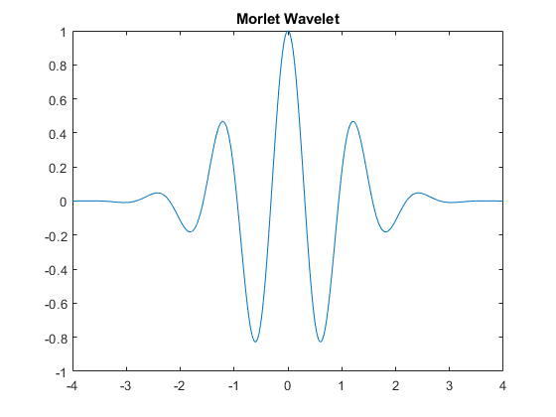

**Fig 4.1:** Morlet Wavelet

These two transforms have the following properties:

* The discrete wavelet transform returns a data vector of the same length as the input is. Usually, even in this vector many data are almost zero. This corresponds to the fact that it decomposes into a set of wavelets (functions) that are orthogonal to its translations and scaling. Therefore, we decompose such a signal to a same or lower number of the wavelet coefficient spectrum as is the number of signal data points. Such a wavelet spectrum is very good for signal processing and compression, for example, as we get no redundant information here.The key application for Discrete Wavelet Transform isdenoising and compression of signals and images.
* The continuous wavelet transform in contrary returns an array one dimension larger than the input data. For a 1D data we obtain an image of the time-frequency plane. We can easily see the signal frequencies evolution during the duration of the signal and compare the spectrum with other signals spectra. As here is used the non-orthogonal set of wavelets, data are highly correlated, so big redundancy is seen here. This helps to see the results in a more humane form.Key applications of the continuous wavelet transform is, time frequency analysis, and filtering of time localized frequency components.

Two important wavelet transform concepts are scaling and shifting. Scaling refers to the process of stretching or shrinking the signal in time. S is the scaling factor, which is a positive value and corresponds to how much a signal is scaled in time. For a wavelet, there is a reciprocal relationship between scale and frequency with a constant of proportionality. This constant of proportionality is called the "center frequency" of the wavelet. This is because, unlike the sinewave, the wavelet has a band pass characteristic in the frequency domain. Therefore when you scale a wavelet by a factor of 2, it results in reducing the equivalent frequency by an octave.A stretched wavelet helps in capturing the slowly varying changes in a signal while a compressed wavelet helps in capturing abrupt changes.

Shifting a wavelet simply means delaying or advancing the onset of the wavelet along the length of the signal. We shift the wavelet to align with the feature we are looking for in a signal.

**4.3.1 Discrete Wavelet Transform**

The discrete wavelet transform (DWT) is an implementation of the wavelet transform using a discrete set of the wavelet scales and translations obeying some defined rules. The discrete wavelet transform or DWT is ideal for denoising and compressing signals and images, as it helps represent many naturally occurring signals and images with fewer coefficients. This enables a sparser representation. The base scale in DWT is set to 2. This transform decomposes the signal into mutually orthogonal set of wavelets, which is the main difference from the continuous wavelet transform (CWT), or its implementation for the discrete time series sometimes called discrete-time continuous wavelet transform (DT-CWT).

The discrete wavelet transform process is equivalent to comparing a signal with discrete multirate filter banks. Given a signal - S, - the signal is first filtered with special lowpass and high pass filter to yield lowpass and highpass sub-bands. We can - refer to these as A1 and D1. Half of the samples are discarded after filtering as per the Nyquist criterion. The filters typically have a small number of coefficients and result in good computational performance. These filters also have the ability to reconstruct the sub bands, while cancelling any aliasing that occurs due to downsampling. For the next level of decomposition, the lowpasssubband (A1) is iteratively filtered by the same technique to yield narrower subbands - A2 and D2 and so on. The length of the coefficients in each sub band is half of the number of coefficients in the preceding stage. With this technique, you can capture the signal of interest with a few large magnitude DWT coefficients, while the noise in the signal results in smaller DWT coefficients.The output of the discrete wavelet transform yields the same number of coefficients as the length of the input signal. Therefore, it requires less memory.It also helps denoise and compress signals.

The wavelet can be constructed from a scaling function which describes its scaling properties. The restriction that the scaling functions must be orthogonal to its discrete translations implies some mathematical conditions on them which are mentioned everywhere, e.g. the dilation equation

**Chapter 5**

**Learning Algorithms**

**5.1 Introduction**

Once the set of features has been defined from the heartbeats, models can be built from these data using artificial intelligencealgorithms from machine domainfor Arrhythmia heartbeat classification. In this chapter we discuss the three popular algorithms: support vector machines (SVM), random forests and decision trees.

**5.2 Machine Learning**

Machine learning (ML) is a field of artificial intelligence that uses statistical techniques to give computer systems the ability to "learn" (e.g., progressively improve performance on a specific task) from data, withoutbeing explicitly programmed. Machine learning explores the study and construction of algorithms that can learn from and make predictions on data – such algorithms overcome following strictly static program instructions by making data-driven predictions or decisions through building a model from sample inputs. Machine learning is employed in a range of computing tasks where designing and programming explicit algorithms with good performance is difficult or infeasible; example applications include email filtering, detection of network intruders, and computer vision.

Machine learning algorithms are often categorized as supervised or unsupervised.

* **Supervised machine learning algorithms** can apply what has been learned in the past to new data using labelled examples to predict future events. Starting from the analysis of a known training dataset, the learning algorithm produces an inferred function to make predictions about the output values. The system is able to provide targets for any new input after sufficient training. The learning algorithm can also compare its output with the correct, intended output and find errors in order to modify the model accordingly.
* In contrast, **unsupervised machine learning algorithms** are used when the information used to train is neither classified nor labelled. Unsupervised learning studies how systems can infer a function to describe a hidden structure from unlabelled data. The system doesn’t figure out the right output, but it explores the data and can draw inferences from datasets to describe hidden structures from unlabelled data.

**5.3 Support Vector Machines (SVM)**

SVM is one of the most popular classifiers found in literature for ECG-based arrhythmia classification methods. In machine learning, support vector machines (SVMs, also support vector networks) are supervised learning models with associated learning algorithms that analyse data used for classification and regression analysis. Given a set of training examples, each marked as belonging to one or the other of two categories, an SVM training algorithm builds a model that assigns new examples to one category or the other, making it a non-probabilistic binary linear classifier.

In addition to performing linear classification, SVMs can efficiently perform a non-linear classification using what is called the kernel trick, implicitly mapping their inputs into high-dimensional feature spaces.

**5.3.1 Motivation**

Classifying data is a common task in machine learning. Suppose some given data points each belong to one of two classes, and the goal is to decide which class a new data point will be in. In the case of support vector machines, a data point is viewed as a p-dimensional vector (a list of p numbers), and we want to know whether we can separate such points with a (p−1)-dimensional hyperplane. This is called a linear classifier. There are many hyperplanes that might classify the data. One reasonable choice as the best hyperplane is the one that represents the largest separation, or margin, between the two classes. So we choose the hyperplane so that the distance from it to the nearest data point on each side is maximized. If such a hyperplane exists, it is known as the maximum-margin hyperplane and the linear classifier it defines is known as a maximum margin classifier; or equivalently, the perceptron of optimal stability.

**5.3.2 Result**

The model took around 20 minutes to train and achieved an accuracy of 87.67%.

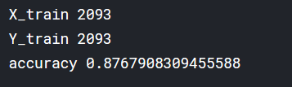

**Fig 5.1:** Accuracy from trained SVM model

**5.4 Random Forests**

Random forests or random decision forests are an ensemble learning method for classification, regression and other tasks, that operate by constructing a multitude of decision trees at training time and outputting the class that is the mode of the classes (classification) or mean prediction (regression) of the individual trees. Random decision forests correct for decision trees' habit of overfitting to their training set.

**5.4.1 Algorithm**

**Decision tree learning:** Decision trees are a popular method for various machine learning tasks. Tree learning "comes closest to meeting the requirements for serving as an off-the-shelf procedure for data mining because it is invariant under scaling and various other transformations of feature values, is robust to inclusion of irrelevant features, and produces inspectable models. However, they are seldom accurate”.

In particular, trees that are grown very deep tend to learn highly irregular patterns: they overfit their training sets, i.e. have low bias, but very high variance. Random forests are a way of averaging multiple deep decision trees, trained on different parts of the same training set, with the goal of reducing the variance. This comes at the expense of a small increase in the bias and some loss of interpretability, but generally greatly boosts the performance in the final model.

**Tree Bagging:** The training algorithm for random forests applies the general technique of bootstrap aggregating, or bagging, to tree learners. Given a training set *X* = *x1*, ...,*xn* with responses *Y* = *y1*, ..., *yn*, bagging repeatedly (*B* times) selects a random sample with replacement of the training set and fits trees to these samples:

For *b* = 1, ...,*B*:

1. Sample, with replacement, *n* training examples from *X*, *Y*; call these *Xb*, *Yb*.
2. Train a classification or regression tree *fb* on *Xb*, *Yb*.

After training, predictions for unseen samples *x'* can be made by averaging the predictions from all the individual regression trees on *x'*:

f ^ = 1 B ∑ b = 1 B f b ( x ′ ) {\displaystyle {\hat {f}}={\frac {1}{B}}\sum _{b=1}^{B}f_{b}(x')}

or by taking the majority vote in the case of classification trees.

This bootstrapping procedure leads to better model performance because it decreases the variance of the model, without increasing the bias. This means that while the predictions of a single tree are highly sensitive to noise in its training set, the average of many trees is not, as long as the trees are not correlated. Simply training many trees on a single training set would give strongly correlated trees (or even the same tree many times, if the training algorithm is deterministic); bootstrap sampling is a way of de-correlating the trees by showing them different training sets.

Additionally, an estimate of the uncertainty of the prediction can be made as the standard deviation of the predictions from all the individual regression trees on *x'*:

σ = ∑ b = 1 B ( f b ( x ′ ) − f ^ ) 2 B − 1 . {\displaystyle \sigma ={\sqrt {\frac {\sum _{b=1}^{B}(f_{b}(x')-{\hat {f}})^{2}}{B-1}}}.}

The number of samples/trees, *B*, is a free parameter. Typically, a few hundred to several thousand trees are used, depending on the size and nature of the training set. An optimal number of trees *B*can be found using cross-validation, or by observing the *out-of-bag error*: the mean prediction error on each training sample *xᵢ*, using only the trees that did not have *xᵢ* in their bootstrap sample.The training and test error tend to level off after some number of trees have been fit.

**From bragging to random forests:**The above procedure describes the original bagging algorithm for trees. Random forests differ in only one way from this general scheme: they use a modified tree learning algorithm that selects, at each candidate split in the learning process, a random subset of the features. This process is sometimes called "feature bagging". The reason for doing this is the correlation of the trees in an ordinary bootstrap sample: if one or a few features are very strong predictors for the response variable (target output), these features will be selected in many of the *B* trees, causing them to become correlated. An analysis of how bagging and random subspace projection contribute to accuracy gains under different conditions is given by Ho.Typically, for a classification problem with *p* features, √*p* (rounded down) features are used in each split.For regression problems the inventors recommend *p/3* (rounded down) with a minimum node size of 5 as the default.

**5.4.2 Result**

The model took around 3 minutes to train and gave an accuracy of 95.68%. The columns of confusion matrix shows total no. of actual heartbeat, and rows shows no of heartbeat classified by the model.

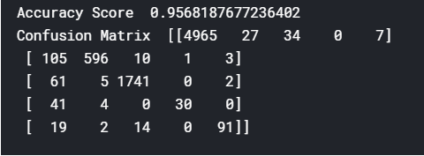

**Fig 5.2:** Accuracy and confusion matrix for Random forest model

**5.5 Decision Trees**

A decision tree is a decision support tool that uses a tree-like model of decisions and their possible consequences, including chance event outcomes, resource costs, and utility. It is one way to display an algorithm that only contains conditional control statements. Decision trees are commonly used in operations research, specifically in decision analysis, to help identify a strategy most likely to reach a goal, but are also a popular tool in machine learning.

A decision tree is a flowchart-like structure in which each internal node represents a "test" on an attribute (e.g. whether a coin flip comes up heads or tails), each branch represents the outcome of the test, and each leaf node represents a class label (decision taken after computing all attributes). The paths from root to leaf represent classification rules. In decision analysis, a decision tree and the closely related influence diagram are used as a visual and analytical decision support tool, where the expected values (or expected utility) of competing alternatives are calculated.

A decision tree consists of three types of nodes:

* Decision nodes – typically represented by squares
* Chance nodes – typically represented by circles
* End nodes – typically represented by triangles

Decision trees are commonly used in operations research and operations management. If, in practice, decisions have to be taken online with no recall under incomplete knowledge, a decision tree should be paralleled by a probability model as a best choice model or online selection model algorithm. Another use of decision trees is as a descriptive means for calculating conditional probabilities.

**5.5.1 Result**

The model took only 1 minute to train and achieved an accuracy of 92.21%. The columns of confusion matrix shows total no. of actual heartbeat, and rows shows no of heartbeat classified by the model.

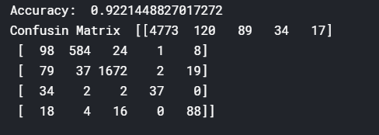

**Fig 5.3:** Accuracy and confusion matrix from trained Decision Tree model

**Chapter 6**

**Results and Conclusion**

**6.1 Summary**

In this project we analyse the ECG data of a patient and predict whether that patient has arrhythmia or not. For this we first take ECG data of patient which is available in the form of samples taken per second. We then pre-process the signal to remove any noise or disturbance from the signal that might have crept in either due to other electrodes or due to outside vibrations. We achieve this with the use of filters. Now we take the preprocessed signal and perform heartbeat segmentation. In heartbeat segmentation, we try to detect the total number of heartbeats by making use of RR interval parameter. This is done using Pan-Tompkins algorithm. Further we take each heartbeat and extract features from them using discrete wavelet transform and then we use those features to devise a model using various machine learning algorithm and check which one gives the maximum accuracy. In this implementation we use support vector machine, random forests and decision trees.

**6.2 Results**

**6.2.1 Phase I and II (Bandpass and filtering stage)**

After applying the Pan Tompkins algorithm on all the 48 patients data,

the sensitivity with which the algorithm detects heartbeat is 95.2%.

And the positive predictivity of the algorithm is 97.1%.

**6.2.2 Phase III (Feature selection)**

Most important feature used for training the model was RR interval and also the DWT approximation coefficients.

The DWT function produces 2 sets of arrays of coefficients corresponding to approximation coefficient and detail coefficient, of which detail coefficients had lower magnitude of the order of 10-3 to 10-4, thus it was neglected and approximation coefficients were used to represent a heartbeat.

**6.2.3 Phase IV (Machine Learning algorithm)**

We trained 3 models on the processed version of MIT-BIH dataset, which are Support Vector Machine (SVM), Random Forest and Decision Tree. There are 5 categories of heartbeat, in which we are classifying and they are:

Category 1: Normal Heartbeat

Category 2: Atrial, nodal and superventricular premature beats.

Category 3: Ventricular premature beats (PVC)

Category 4: Escape beats

Category 5: Ventricular flutter/fibrillation

**6.2.4 Intra-patient heartbeat classification accuracy:**

The model is trained on 75% heartbeat data of 43 patients out of 48 patients and tested on the 25% of remaining heartbeats of those 43 patients.

SVM takes approximately 30 minutes to train and has classification accuracy of 82%.

Random Forest takes approximately 3 minutes to train and has classification accuracy of 95.68%.

Below image shows the confusion matrix of the random forest.

Decision Tree takes approximately 1 minute to train and has classification accuracy of 92.21%.

Below image shows the confusion matrix of the random forest.

**6.2.5 Inter-patient heartbeat classification accuracy:**

The trained model is then tested of the remaining 5 patients to check for the Arrthymia. The prediction those random 5 patients are:

For patient no. 201:

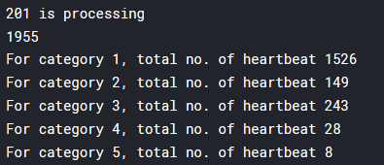

**Fig 6.1:** Heartbeat classification result of patient no. 201

From this we see that, patient had 149 beat of category 2, 243 beats of category 3, 28 beats of category 4 and 8 beats of category 5.

So the patient is suffering from Ventricular premature beats (PVC).

For patient no. 215:

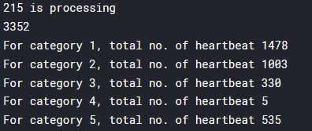

**Fig 6.2:** Heartbeat classification result of patient no. 215

From this we see that, patient had 1003 beat of category 2, 330 beats of category 3, 5 beats of category 4 and 535 beats of category 5.

So the patient is suffering from atrial, nodal and superventricular premature beats.

For patient no. 115:

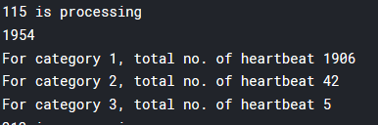

**Fig 6.3:** Heartbeat classification result of patient no. 115

From this we see that, patient had 42 beat of category 2, 5 beats of category 3.

So the patient is healthy as no. of heartbeat of category 2 is below average.

For patient no. 212:

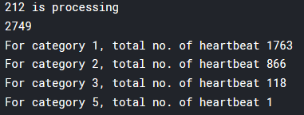

**Fig 6.4:** Heartbeat classification result of patient no. 212

From this we see that, patient had 866 beat of category 2, 118 beats of category 3, 5 beats of category 4 and 1 beats of category 5.

So the patient is suffering from atrial, nodal and superventricular premature beats.

For patient no. 203:

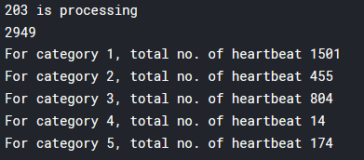

**Fig 6.5:** Heartbeat classification result of patient no. 203

From this we see that, patient had 455 beat of category 2, 804 beats of category 3, 14 beats of category 4 and 174 beats of category 5.

So the patient is suffering from Ventricular premature beats (PVC).

**6.3 Future Scope**

Our implementation of this automated system for identification of arrhythmia depends on samples of ECG data taken from the analog signal at a particular frequency. For better usage a hardware solution can be provided which would eliminate the need for such data and would simply work using real time analog data from a patient for much smoother detection.

The current implementation is done on a computer system and has much more hardware requirements which can be reduced by using a cloud computing solution and serving it up with the help of a mobile application. This will reduce the overall cost of implementing such a system and it would be readily available for usage.

We can make use of more advanced machine learning algorithms and check if we can get better accuracy. Currently we make use of SVM, decision trees and random forests. We can make use of artificial neural networks and other sophisticated algorithms to further this obtained accuracy.

**References**

[1] E.J. da S. Luz, W.R. Schwartz, G. Cmara-Chvez, D. Menotti, ECG-based heartbeat classification for arrhythmia detection: a survey, Comput. Methods Prog.Biomed.127 (Suppl. C) (2016) 144–164.

[2] J. Pan and W. J. Tompkins, “A real-time QRS detection algorithm.” IEEE Trans. on Bio-Medical Engineering, vol. 32, no. 3, pp. 230–6, Mar. 1985.

[3] A.L. Goldberger, L.A.N. Amaral, L. Glass, J.M. Hausdorff, P.C.Ivanov, R.G. Mark, J.E. Mietus, G.B. Moody, C.-K. Peng, H.E.Stanley, Physiobank, physiotoolkit, and physionet:Components of a new research resource for complex physiologic signals, Circulation 101 (23) (2000) 215–220,database and tools available at: http://www.physionet.org/.

[4] MG Tsipoyras, DI Fotiadis, D Sideris, “Arrhythmia Classification using the RR-Interval Duration Signal” Computers in Cardiology, 2002;29: 485-488

[5] Sanamdikar, S. T., S. T. Hamde, and V. G. Asutkar. "A literature review on arrhythmia analysis of ECG Signal." International Research Journal of Engineering and Technology 2.3 (2015): 307-312.

[6] Wikipedia contributors. (2018, October 17). Electrocardiography. In Wikipedia, The Free Encyclopedia. Retrieved 15:02, November 18, 2018, from (<https://en.wikipedia.org/w/index.php?title=Electrocardiography&oldid=864528834>)

[7] Wikipedia contributors. (2018, November 16). Random forest. In Wikipedia, The Free Encyclopedia. Retrieved 15:06, November 18, 2018, from <https://en.wikipedia.org/w/index.php?title=Random_forest&oldid=869188749>

[8] Arrhythmia article by American Heart Association (<http://www.heart.org/en/health-topics/arrhythmia>).